European Championship Preview
Rui Oliveira

The three powerhouses
One year ago, Noah Boeken defeated Raphaël Lévy in the European Championship finals. At the time, the Magic community had just been shaken by the Masters Series: an injection of money and new tournament levels that could, for the first time, allow the best players in the game to pursue a full-time Magic career.
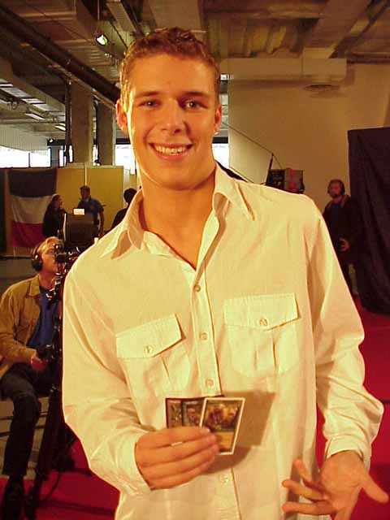
In that time of new hopes and challenges, the young champion, unwittingly, revealed the start of one of the stories that would mark the last twelve months of European Magic. In his interview Noah told us: "I was ecstatic when I found out that Ryan Fuller won Canadian Nationals this year. I first met him at Pro Tour-Chicago, and we became good friends. He stayed at my place in Amsterdam for a week, and he's coming again for Worlds."
In the following months, their friendship and success convinced Fuller to move to Amsterdam and change his DCI affiliation to the Netherlands. They finished twenty and twenty-fifth in last year's Worlds and have rocked the European circuit ever since, winning one individual Grand Prix each and taking the Tokyo Masters title as part of their team with Chris Benafel.
But the Netherlands isn't just Boeken and Fuller. In fact, the Dutch have an impressive squad of brilliant players: Kamiel Cornelissen, Bram Snepvangers, national champion Tom van de Logt, Frank Karsten, Alexander Witt, Jelger Wiegersma, Joost Vollebregt and Jos Schreurs, just to name a few of the huge Dutch delegation for the upcoming European Championships.
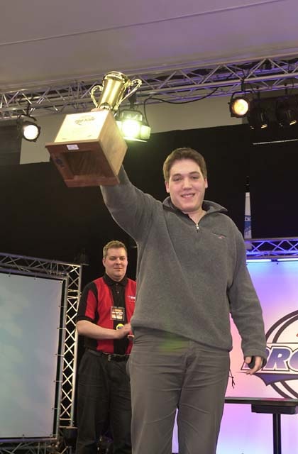
Of course, the other big story in Europe right now is all about a silent dream crusher known as Kai Budde. The German, who demolished the Magic scene with his explosive 1998-1999 rookie season, again upped the stakes this year by becoming the first player to win two Pro Tours in the same season. Backed by a formidable team, Kai won a Pro Tour in each of the Euros formats: Invasion Block Rochester (albeit without Apocalypse) in Barcelona and Standard in New York.
If that isn't enough to scare the other contenders, they only have to look at the rest of the German players. Kai is only the tip of a very strong iceberg. Patrick Mello, Dominik Hothow, Stephan Valkyser, Janosch KÜhn, André Konstanczer, national champion Daniel Zink, Christian LÜhrs, André Delere and three-time Grand Prix winner Jim Herold are the best-known names in the first-rate German squad.
Last year Raphaël Lévy lost in a very tight final. Doesn't the name sound familiar? Well, Raphaël is what we could call a Euros specialist, making the Top 4 in the last two years, losing in the semifinals in 1999 and in the finals last year. Is 2001 the year of the perennial French? Lévy is not the only reason the French have high hopes for this year. The Ruel brothers, national champion Pierre Malherbaud, Yann Hamon, Franck Canu, Nicolas Labarre, Wielfried Ranque, Antoine Menard, Nicolas Olivieri and Manuel Bevand all had their impact on European Magic, and most of them even on World Magic, so expect only the best from them.
Across the English Channel, most of England's aspirations rest squarely on the overworked shoulders of the famous Hampton Court Palace trinity: Ben Ronaldson, Warren Marsh and John Ormerod. They are the English part of an international team that includes Pro Tour Champions Zvi Mowshowitz, Scott Johns and Kai Budde and has created the last two Constructed Pro Tour winning decks.
A big part of what makes them so respected and admired is their sheer commitment to success, not only in testing marathons, but also during the tournament. In a three-day tournament, like Euros, that kind of team commitment can be crucial. Although they will probably work within their own team, the rest of the English crew will obviously be a part of that process. Names like national champion Oliver Schneider, Mark Wraith, Ellis Romero, Neil Rigby, Scott Wills, Ivan Ronaldson and Craig Jones, have the skill, with the right deck on the second day, to do very well.

The Nordic Menace
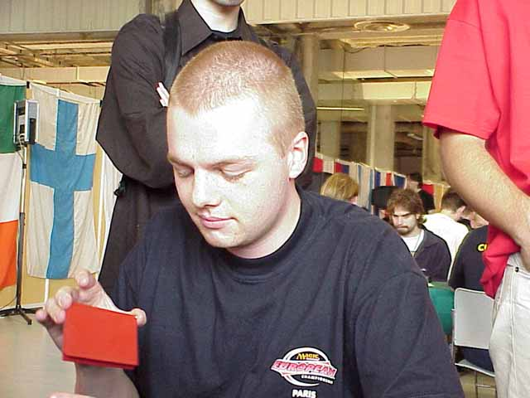
First, the Viking invasion came storming in from the north. In 1999 Nicolai Herzog won Norway's national championship and then Euros replacing his compatriot Sturla Bingen. He won the national crown again this year and is looking to repeat the double.
Among the top names from the Nordic and central nations we have Eivind Nitter from Norway, American-born Trey Van Cleave and Niels Jensen from Denmark, Mattias Jorstedt, Jens Thoren and Duelist Invitational champion and five-time Pro Tour Top 8 Olle Rade from Sweden, Tuomo Nieminen, two-time Pro Tour winner Tommi Hovi, Tomi Walamies, Arto Hiltunen from Finland, Benedikt Klauser and Thomas Preyer from Austria, former World champion Jakub Slemr from the Czech Republic and Konstatin Firsov from the Russian Federation.

The Southern Rising Stars
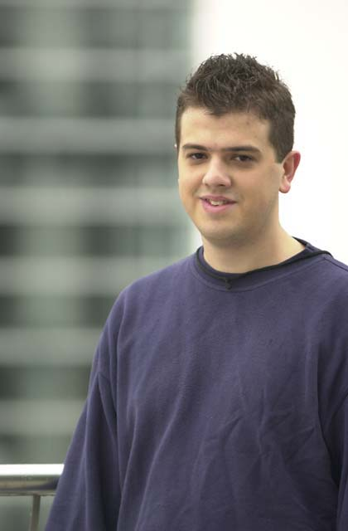
The final group to consider is the Latin connection (Italy-Spain-Portugal). Although they don't have the long history of success of their fellow Europeans from the north Portugal's Frederico Bastos reached the Top 8 at Pro Tour Tokyo and Italy got a big boost from their Florida-import Antonino De Rosa. Those two factors combined with a Pro Tour in Spain (Barcelona) sparked the interest and serious competition in these countries. Spain's golden trio of Roc Herms Pont, Carlos Barrado and Hector Fuentes, Rui Mariani and Helder Coelho from Portugal and Italy's own national champion Matteo Di Tomaso and Federico Dato (who finished fourth at Pro Tour-Rome a few years ago) all have what it takes to take the trophy south, for a change.

The Battlefield
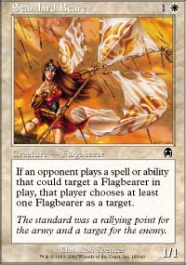
The first day of the tournament will be Invasion-Planeshift-Apocalypse Rochester Draft. With the recent arrival of Apocalypse this format will be all about the last month of testing. Flagbearers and opposite colored gold cards added a new twist to an already complicated environment.
So the key here seems to be working against the clock. Almost everything you knew about Invasion-Invasion-Planeshift Rochester goes out the window and we start from scratch. The best results will probably come from players who either practiced hard during these few days or benefit from someone else's learning experience and rely mostly on their Limited skills to pull it off.
Finding the best combination, or the best combination of the underdrafted colors, might spell the difference between having a comfortable Saturday or sweeping the Standard just for a shot at playing on Sunday.
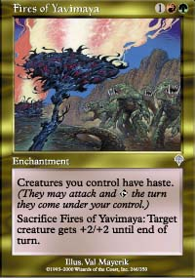
The second day will be Standard (without Apocalypse), another very interesting format. Since this is the very last format without Apocalypse, which rotates in on the following day, the big teams have no need to hold back to save decks for Worlds. So expect everyone to bring his or her best decks to the tournament. Since the Standard portion is one the second day players are already working with their first day results to make the deck choice.
Standard, based upon the U.S. Nationals results, doesn't seem to have a fixed universe. Fires is considered by most the best deck but most of the other decks are adapting at a very fast rate. Orb-Opposition decks seemed the answer until Yavimaya Barbarians came into the scene so they need to adapt once again.
Expect the English-American-German connection to, once again, scour the metagame for a loophole. The recent French-Dutch testing teams seem to be impressive as well. If there is a way to break the environment, these teams will find it and, if not, you can rely on them for some metagame tricks and finely tuned decks.
No matter who wins, the competition will be fierce and fascinating to watch. The game level is climbing at an incredible pace and the players that manage to keep up may soon find themselves in a whole new crowd. The elite few might live out the dream started by the Masters series announcement a year ago: being a true professional Magic player.
Good luck to all and don't forget to follow the action right here on Sideboard.

